D.Y. Patil College Of Engineering & Technology, Kolhapur
Department of Computer Science & Engineering
(Artificial Intelligence & Machine Learning)

Lab Manual

Introduction to Machine Learning

T. Y COMPUTER SCIENCE & ENGINEERING
(Artificial Intelligence & Machine Learning)



Department Of Computer Science & Engineering(Artificial Intelligence &Machine Learning)
- Department Vision and Mission:

- Vision:
To create technocrats with a flair of advanced technology in Computer Science and Engineering so as to satisfy the Industrial and Societal needs.
- Mission:
M1: To facilitate students with latest hardware, software technologies and technical expertise.
M2: To inspire and nurture creativity amongst the students.
M3: To make the students industry ready and inculcate entrepreneurship skills.
M4: To enrich students’ technical skills for finding innovative solutions to societal needs.

- Program Educational Objectives (PEOs):
PEO1: To apply the knowledge of mathematics and computer science and engineering to provide realistic solutions to the problems in their domain.

PEO2: To exhibit technical skills to analyze, design and develop solutions for engineering issues by using innovative methods, cutting edge tools and techniques.

PEO3: To apply professional practices, ethical principles and improve communication skills to enhance the career avenues.

PEO4: To display thirst for emerging technologies and inquisitiveness to tackle societal and environmental needs.

Department of Computer Science & Engineering
(Artificial Intelligence & Machine Learning), Kolhapur

Name of the course –Introduction to Machine Learning
Class–TY

Practical-2Hrs/Week

List of Experiment

Ass.No. | Name of Assignment | S/O | Hours
1 | Implementation of simple Linear Regression | O | 2
2 | Implementation of Multivariate Linear Regression | O | 2
3 | Implementation of Logistic Regression for Binary Classification | O | 2
4 | Implementation of Multiclass Classification | O | 2
5 | Implementation of KNN Classifier | O | 2
6 | Implementation of Naïve Bayes Classifier | O | 2
7 | Implementation of Bayesian Network | O | 2
8 | Implementation of Decision Tree | O | 2
9 | Implementation of SVM | O | 2
10 | Implementation of K-means Clustering | O | 2
11 | Implementation of Agglomerative Clustering | O | 2
12 | Design and analysis of sentiment analysis model | O | 2

Subject Incharge

Mrs. P. S. Gholap HOD (AIML)

ExperimentNo-01

Title:-Implementation of simple Linear Regression
Aim:ToStudyImplementationofsimple Linear Regression

Theory:-
Linear Regression

Linear regression is one of the easiest and most popular Machine Learning algorithms. It is a statistical method that is used for predictive analysis. Linear regression makes predictions for continuous/real or numeric variables such as sales, salary, age, product price, etc.
Linear regression algorithm shows a linear relationship between a dependent (y) and one or more independent (y) variables, hence called as linear regression. Since linear regression shows the linear relationship, which means it finds how the value of the dependent variable is changing according to the value of the independent variable.
The linear regression model provides a sloped straight line representing the relationship between the variables. Consider the below image:

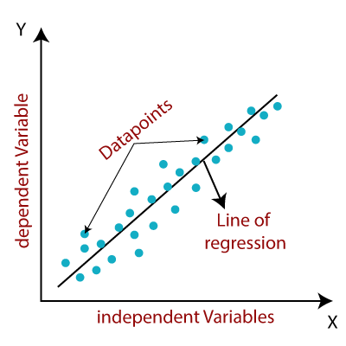

Figure1.Linear Regression

y= a₀+a₁x+ ε
Here,
Y=Dependent Variable (Target Variable)
X= Independent Variable (predictor Variable)
a0= intercept of the line (Gives an additional degree of freedom)
a1 = Linear regression coefficient (scale factor to each input value).
ε = random error

The values for x and y variables are training datasets for Linear Regression model representation.

Linear Regression Line
A linear line showing the relationship between the dependent and independent variables is called a regression line. A regression line can show two types of relationship:
- Positive Linear Relationship:
If the dependent variable increases on the Y-axis and independent variable increases on X-axis, then such a relationship is termed as a Positive linear relationship.
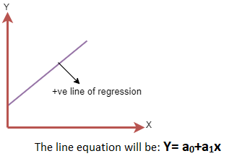
- Negative Linear Relationship:
If the dependent variable decreases on the Y-axis and independent variable increases on the X-axis, then such a relationship is called a negative linear relationship.

Finding the best fit line:
When working with linear regression, our main goal is to find the best fit line that means the error between predicted values and actual values should be minimized. The best fit line will have the least error.
The different values for weights or the coefficient of lines (a₀, a₁) gives a different line of regression, so we need to calculate the best values for a₀ and a₁ to find the best fit line, so to calculate this we use cost function.

Implementaion of Linear Regression

import numpy as nm
import matplotlib.pyplot as mtp
import pandas as pd

data_set= pd.read_csv('Salary_Data.csv')

x= data_set.iloc[:, :-1].values
y= data_set.iloc[:, 1].values

# Splitting the dataset into training and test set.
from sklearn.model_selection import train_test_split
x_train, x_test, y_train, y_test= train_test_split(x, y, test_size= 1/3, random_state=0)

#Fitting the Simple Linear Regression model to the training dataset
from sklearn.linear_model import LinearRegression
regressor= LinearRegression()
regressor.fit(x_train, y_train)

Output:
Out[7]: LinearRegression(copy_X=True, fit_intercept=True, n_jobs=None, normalize=False)

Prediction of test set result:

#Prediction of Test and Training set result
y_pred= regressor.predict(x_test)
x_pred= regressor.predict(x_train)

visualizing the Training set results:
mtp.scatter(x_train, y_train, color="green")
mtp.plot(x_train, x_pred, color="red")
mtp.title("Salary vs Experience (Training Dataset)")
mtp.xlabel("Years of Experience")

mtp.ylabel("Salary(In Rupees)")
mtp.show()

Output:
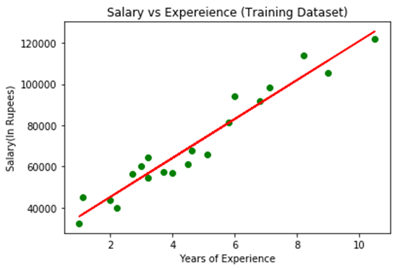
visualizing the Test set results:
#visualizing the Test set results
mtp.scatter(x_test, y_test, color="blue")
mtp.plot(x_train, x_pred, color="red")
mtp.title("Salary vs Experience (Test Dataset)")
mtp.xlabel("Years of Experience")
mtp.ylabel("Salary(In Rupees)")
mtp.show()

Output:
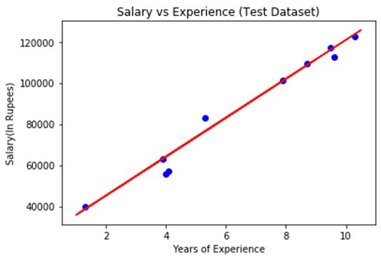

Conclusion:
Briefly studied implementation of Linear Regression

Experiment No - 02

Title:- Implementation of Multivariate Linear Regression.
Aim: To implement Multivariate Linear Regression.

Theory:-

Multivariate Regression
Multivariate regression is an extension of simple linear regression. It is used when we want to predict the value of a variable based on the value of two or more different variables. The variable we want to predict is called the Dependent Variable, while those used to calculate the dependent variable are termed as Independent Variables.
The mathematical function/hypothesis of a Multivariate regression is of the form:
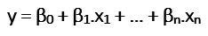
where, n represents the number of independent variables, β0~ βn represent the coefficients and x1~xn, are the independent variable
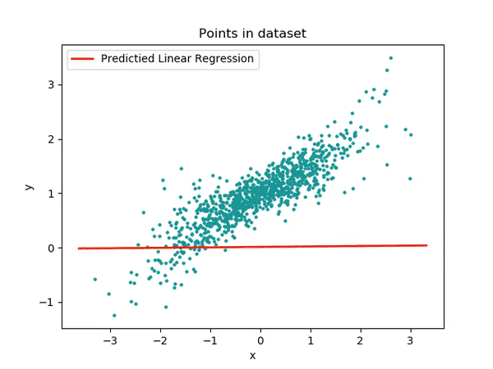

Figure 3. Points in dataset

Using a multivariate model helps us compare coefficients across outcomes. What makes a multivariate or multiple linear regression a better model is a small cost function.

Implementation of Multivariate Regression
#Importing the libraries and and reading the data into a Pandas DataFrameimport pandas as pd
import numpy as np
import matplotlib.pyplot as plt
import seaborn as snstest=pd.read_csv("california_housing_test.csv")
train=pd.read_csv("california_housing_train.csv")

#Visuaising our data using Seaborn Libraryplt.figure()
sns.heatmap(data.corr(), cmap='coolwarm')
plt.show()sns.lmplot(x='median_income', y='median_house_value', data=train)
sns.lmplot(x='housing_median_age', y='median_house_value', data=train)

data = data[[‘total_rooms’, ‘total_bedrooms’, ‘housing_median_age’, ‘median_income’, ‘population’, ‘households’]]
data.info()data['total_rooms'] = data['total_rooms'].fillna(data['total_rooms'].mean())
data['total_bedrooms'] = data['total_bedrooms'].fillna(data['total_bedrooms'].mean())

#Splitting training and testing datafrom sklearn.model_selection import train_test_split
X_train, X_test, y_train, y_test = train_test_split(train, y, test_size = 0.2, random_state = 0)
y_train = y_train.reshape(-1,1)
y_test = y_test.reshape(-1,1)

#Fitting the model on training datafrom sklearn.linear_model import LinearRegression
regressor = LinearRegression()
regressor.fit(X_train, y_train)#Calculating the Intercept and Coefficientprint(regressor.intercept_)
print(regressor.coef_)

predictions = regressor.predict(X_test)
predictions = predictions.reshape(-1,1)#Calculate RMSE of the modelfrom sklearn.metrics import mean_squared_error
print(‘MSE:’, mean_squared_error(y_test,predictions))
print(‘RMSE:’, np.sqrt(mean_squared_error(y_test,predictions)))

The RMSE for our model is 0.6628934048044981
Conclusion:
Briefly studied Multivariate regression

Experiment No - 03

Title:- Implementation of Logistic Regression for Binary Classification
Aim: To study Implementation of Logistic Regression for Binary Classification

Theory:-

Logistic regression is a supervised learning classification algorithm used to predict the probability of a target variable. The nature of target or dependent variable is dichotomous, which means there would be only two possible classes.
In simple words, the dependent variable is binary in nature having data coded as either 1 (stands for success/yes) or 0 (stands for failure/no).
Mathematically, a logistic regression model predicts P(Y=1) as a function of X. It is one of the simplest ML algorithms that can be used for various classification problems such as spam detection, Diabetes prediction, cancer detection etc.
Generally, logistic regression means binary logistic regression having binary target variables, but there can be two more categories of target variables that can be predicted by it. Based on those number of categories, Logistic regression can be divided into following types −

Binary or Binomial
In such a kind of classification, a dependent variable will have only two possible types either 1 and 0. For example, these variables may represent success or failure, yes or no, win or loss etc.

Multinomial
In such a kind of classification, dependent variable can have 3 or more possible unordered types or the types having no quantitative significance. For example, these variables may represent “Type A” or “Type B” or “Type C”.

Ordinal
In such a kind of classification, dependent variable can have 3 or more possible ordered types or the types having a quantitative significance. For example, these variables may represent “poor” or “good”, “very good”, “Excellent” and each category can have the scores like 0,1,2,3.

Binary Logistic Regression model
The simplest form of logistic regression is binary or binomial logistic regression in which the target or dependent variable can have only 2 possible types either 1 or 0. It allows us to model a relationship between multiple predictor variables and a binary/binomial target variable. In case of logistic regression, the linear function is basically used as an input to another function such as 𝑔 in the following relation −
hθ(x)=g(θTx)where0≤hθ≤1
Here, 𝑔 is the logistic or sigmoid function which can be given as follows –
g(z)=11+e−zwherez=θTx
To sigmoid curve can be represented with the help of following graph. We can see the values of y-axis lie between 0 and 1 and crosses the axis at 0.5.
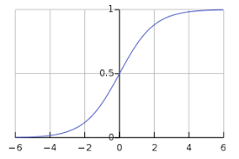
The classes can be divided into positive or negative. The output comes under the probability of positive class if it lies between 0 and 1. For our implementation, we are interpreting the output of hypothesis function as positive if it is ≥0.5, otherwise negative.
We also need to define a loss function to measure how well the algorithm performs using the weights on functions, represented by theta as follows −
ℎ=𝑔(𝑋𝜃)
J(θ)=1m.(−yTlog(h)−(1−y)Tlog(1−h))
Now, after defining the loss function our prime goal is to minimize the loss function. It can be done with the help of fitting the weights which means by increasing or decreasing the weights. With the help of derivatives of the loss function w.r.t each weight, we would be able to know what parameters should have high weight and what should have smaller weight.
The following gradient descent equation tells us how loss would change if we modified the parameters −
δJ(θ)δθj=1mXT(g(Xθ)−y)

Implementation of Logistic Regression for Binary Classification

import numpy as np
import matplotlib.pyplot as plt
import seaborn as sns
from sklearn import datasets
iris = datasets.load_iris()
X = iris.data[:, :2]
y = (iris.target != 0) * 1

plt.figure(figsize=(6, 6))
plt.scatter(X[y == 0][:, 0], X[y == 0][:, 1], color='g', label='0')
plt.scatter(X[y == 1][:, 0], X[y == 1][:, 1], color='y', label='1')
plt.legend();

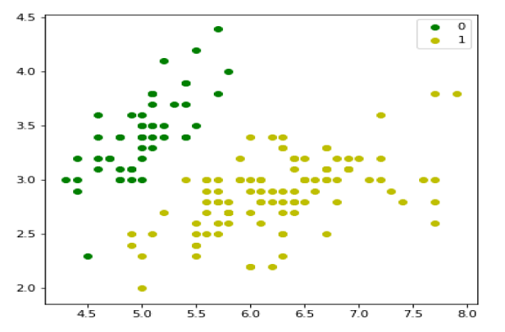
Next, we will define sigmoid function, loss function and gradient descend as follows −
class LogisticRegression:
def __init__(self, lr=0.01, num_iter=100000, fit_intercept=True, verbose=False):
self.lr = lr
self.num_iter = num_iter
self.fit_intercept = fit_intercept
self.verbose = verbose
def __add_intercept(self, X):
intercept = np.ones((X.shape[0], 1))
return np.concatenate((intercept, X), axis=1)
def __sigmoid(self, z):
return 1 / (1 + np.exp(-z))
def __loss(self, h, y):
return (-y * np.log(h) - (1 - y) * np.log(1 - h)).mean()
def fit(self, X, y):
if self.fit_intercept:
X = self.__add_intercept(X)
Now, initialize the weights as follows −
self.theta = np.zeros(X.shape[1])
for i in range(self.num_iter):
z = np.dot(X, self.theta)
h = self.__sigmoid(z)
gradient = np.dot(X.T, (h - y)) / y.size
self.theta -= self.lr * gradient
z = np.dot(X, self.theta)
h = self.__sigmoid(z)
loss = self.__loss(h, y)
if(self.verbose ==True and i % 10000 == 0):
print(f'loss: {loss} \t')

def predict_prob(self, X):
if self.fit_intercept:
X = self.__add_intercept(X)
return self.__sigmoid(np.dot(X, self.theta))
def predict(self, X):
return self.predict_prob(X).round()

model = LogisticRegression(lr=0.1, num_iter=300000)
preds = model.predict(X)
(preds == y).mean()

plt.figure(figsize=(10, 6))
plt.scatter(X[y == 0][:, 0], X[y == 0][:, 1], color='g', label='0')
plt.scatter(X[y == 1][:, 0], X[y == 1][:, 1], color='y', label='1')
plt.legend()
x1_min, x1_max = X[:,0].min(), X[:,0].max(),
x2_min, x2_max = X[:,1].min(), X[:,1].max(),
xx1, xx2 = np.meshgrid(np.linspace(x1_min, x1_max), np.linspace(x2_min, x2_max))
grid = np.c_[xx1.ravel(), xx2.ravel()]
probs = model.predict_prob(grid).reshape(xx1.shape)
plt.contour(xx1, xx2, probs, [0.5], linewidths=1, colors='red');

Conclusion:
Briefly studied Logistic Regression for Binary Classification

Experiment No - 04

Title:- Implementation of Multiclass Classification.
Aim: To Study Multiclass Classification

Theory:-

Problem – Given a dataset of m training examples, each of which contains information in the form of various features and a label. Each label corresponds to a class, to which the training example belongs. In multiclass classification, we have a finite set of classes. Each training example also has n features.
For example, in the case of identification of different types of fruits, “Shape”, “Color”, “Radius” can be featured, and “Apple”, “Orange”, “Banana” can be different class labels.
In a multiclass classification, we train a classifier using our training data and use this classifier for classifying new examples.

Decision tree classifier – A decision tree classifier is a systematic approach for multiclass classification. It poses a set of questions to the dataset (related to its attributes/features). The decision tree classification algorithm can be visualized on a binary tree. On the root and each of the internal nodes, a question is posed and the data on that node is further split into separate records that have different characteristics. The leaves of the tree refer to the classes in which the dataset is split. In the following code snippet, we train a decision tree classifier in scikit-learn.

Implementation of Decision tree classifier

# importing necessary libraries
from sklearn import datasets
from sklearn.metrics import confusion_matrix
from sklearn.model_selection import train_test_split
# loading the iris dataset
iris = datasets.load_iris()
# X -> features, y -> label
X = iris.data
y = iris.target
# dividing X, y into train and test data
X_train, X_test, y_train, y_test = train_test_split(X, y, random_state = 0)

training a DescisionTreeClassifier
from sklearn.tree import DecisionTreeClassifier
dtree_model = DecisionTreeClassifier(max_depth = 2).fit(X_train, y_train)
dtree_predictions = dtree_model.predict(X_test)
# creating a confusion matrix
cm = confusion_matrix(y_test, dtree_predictions)

Conclusion:

Briefly studied Multiclass classification

Experiment No - 05

Title:- Implementation of KNN Classifier.
Aim: Implementation of KNN Classifier

Theory:-

- K-Nearest Neighbour is one of the simplest Machine Learning algorithms based on Supervised Learning technique.
- K-NN algorithm assumes the similarity between the new case/data and available cases and put the new case into the category that is most similar to the available categories.
- K-NN algorithm stores all the available data and classifies a new data point based on the similarity. This means when new data appears then it can be easily classified into a well suite category by using K- NN algorithm.
- K-NN algorithm can be used for Regression as well as for Classification but mostly it is used for the Classification problems.
- K-NN is a non-parametric algorithm, which means it does not make any assumption on underlying data.
- It is also called a lazy learner algorithm because it does not learn from the training set immediately instead it stores the dataset and at the time of classification, it performs an action on the dataset.
- KNN algorithm at the training phase just stores the dataset and when it gets new data, then it classifies that data into a category that is much similar to the new data.
- Example: Suppose, we have an image of a creature that looks similar to cat and dog, but we want to know either it is a cat or dog. So for this identification, we can use the KNN algorithm, as it works on a similarity measure. Our KNN model will find the similar features of the new data set to the cats and dogs images and based on the most similar features it will put it in either cat or dog category.
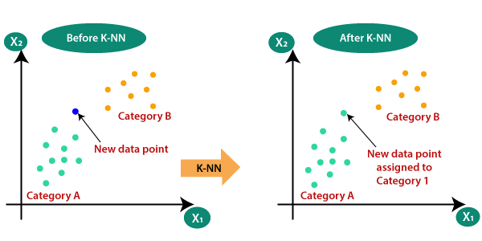

How does K-NN work?
The K-NN working can be explained on the basis of the below algorithm:
- Step-1: Select the number K of the neighbors
- Step-2: Calculate the Euclidean distance of K number of neighbors
- Step-3: Take the K nearest neighbors as per the calculated Euclidean distance.
- Step-4: Among these k neighbors, count the number of the data points in each category.
- Step-5: Assign the new data points to that category for which the number of the neighbor is maximum.
- Step-6: Our model is ready.
Suppose we have a new data point and we need to put it in the required category. Consider the below image:
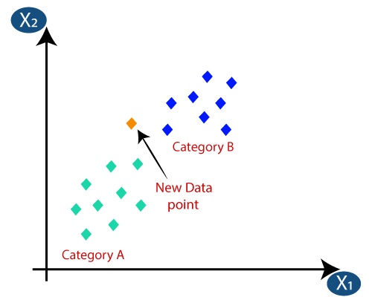
- Firstly, we will choose the number of neighbors, so we will choose the k=5.
- Next, we will calculate the Euclidean distance between the data points. The Euclidean distance is the distance between two points, which we have already studied in geometry. It can be calculated as:
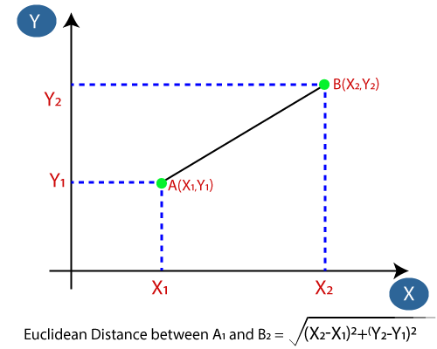
- By calculating the Euclidean distance we got the nearest neighbors, as three nearest neighbors in category A and two nearest neighbors in category B. Consider the below image:
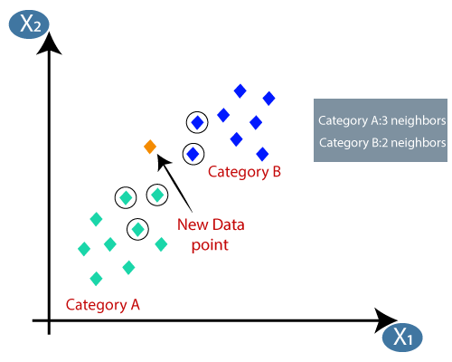

- As we can see the 3 nearest neighbors are from category A, hence this new data point must belong to category A.

Implementation of KNN Algorithm
#importing libraries
import numpy as nm
import matplotlib.pyplot as mtp
import pandas as pd
#importing datasets
data_set= pd.read_csv('user_data.csv')
#Extracting Independent and dependent Variable
x= data_set.iloc[:, [2,3]].values
y= data_set.iloc[:, 4].values
# Splitting the dataset into training and test set.
from sklearn.model_selection import train_test_split
x_train, x_test, y_train, y_test= train_test_split(x, y, test_size= 0.25, random_state=0)
#feature Scaling
from sklearn.preprocessing import StandardScaler
st_x= StandardScaler()
x_train= st_x.fit_transform(x_train)
x_test= st_x.transform(x_test)
#Fitting K-NN classifier to the training set
from sklearn.neighbors import KNeighborsClassifier
classifier= KNeighborsClassifier(n_neighbors=5, metric='minkowski', p=2 )
classifier.fit(x_train, y_train)
Out[10]:
KNeighborsClassifier(algorithm='auto', leaf_size=30, metric='minkowski',
metric_params=None, n_jobs=None, n_neighbors=5, p=2,
weights='uniform')
#Predicting the test set result
y_pred= classifier.predict(x_test)

Conclusion:
Briefly studied Working and Implementation K-NN classifier.

Experiment No - 06

Title:- Implementation of Naïve Bayes Classifier
Aim: Implementation of Naïve Bayes Classifier

Theory:-
- Naïve Bayes algorithm is a supervised learning algorithm, which is based on Bayes theorem and used for solving classification problems.
- It is mainly used in text classification that includes a high-dimensional training dataset.
- Naïve Bayes Classifier is one of the simple and most effective Classification algorithms which helps in building the fast machine learning models that can make quick predictions.
- It is a probabilistic classifier, which means it predicts on the basis of the probability of an object.
- Naïve: It is called Naïve because it assumes that the occurrence of a certain feature is independent of the occurrence of other features. Such as if the fruit is identified on the bases of color, shape, and taste, then red, spherical, and sweet fruit is recognized as an apple. Hence each feature individually contributes to identify that it is an apple without depending on each other.
- Bayes: It is called Bayes because it depends on the principle of Bayes' Theorem.

Bayes' Theorem:
- Bayes' theorem is also known as Bayes' Rule or Bayes' law, which is used to determine the probability of a hypothesis with prior knowledge. It depends on the conditional probability.
- The formula for Bayes' theorem is given as:
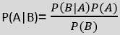
Where,
P(A|B) is Posterior probability: Probability of hypothesis A on the observed event B.
P(B|A) is Likelihood probability: Probability of the evidence given that the probability of a hypothesis is true.
P(A) is Prior Probability: Probability of hypothesis before observing the evidence.
P(B) is Marginal Probability: Probability of Evidence.

Working of Naïve Bayes' Classifier:
Suppose we have a dataset of weather conditions and corresponding target variable "Play". So using this dataset we need to decide that whether we should play or not on a particular day according to the weather conditions. So to solve this problem, we need to follow the below steps:

- Convert the given dataset into frequency tables.
- Generate Likelihood table by finding the probabilities of given features.
- Now, use Bayes theorem to calculate the posterior probability.
Implementation
import numpy as nm
import matplotlib.pyplot as mtp
import pandas as pd

# Importing the dataset
dataset = pd.read_csv('user_data.csv')
x = dataset.iloc[:, [2, 3]].values
y = dataset.iloc[:, 4].values

# Splitting the dataset into the Training set and Test set
from sklearn.model_selection import train_test_split
x_train, x_test, y_train, y_test = train_test_split(x, y, test_size = 0.25, random_state = 0)
# Feature Scaling
from sklearn.preprocessing import StandardScaler
sc = StandardScaler()
x_train = sc.fit_transform(x_train)
x_test = sc.transform(x_test)

Experiment No - 07

Title:- Implementation of Bayesian Network

Aim: Implementation of Bayesian Network

Theory:-
"A Bayesian network is a probabilistic graphical model which represents a set of variables and their conditional dependencies using a directed acyclic graph."
Bayesian networks are probabilistic, because these networks are built from a probability distribution, and also use probability theory for prediction and anomaly detection.
A Bayesian network graph is made up of nodes and Arcs (directed links), where:
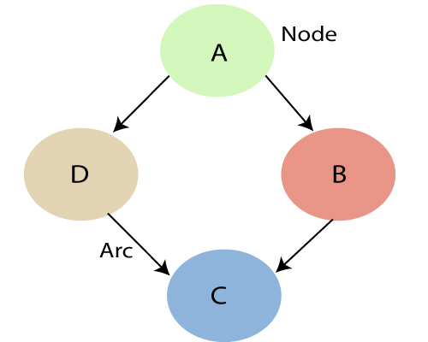
- Each node corresponds to the random variables, and a variable can be continuous or discrete.
- Arc or directed arrows represent the causal relationship or conditional probabilities between random variables. These directed links or arrows connect the pair of nodes in the graph.
These links represent that one node directly influence the other node, and if there is no directed link that means that nodes are independent with each other
  - In the above diagram, A, B, C, and D are random variables represented by the nodes of the network graph.
  - If we are considering node B, which is connected with node A by a directed arrow, then node A is called the parent of Node B.
  - Node C is independent of node A.
- Each node in the Bayesian network has condition probability distribution P(X_{i} |Parent(X_{i}) ), which determines the effect of the parent on that node.
- Bayesian network is based on Joint probability distribution and conditional probability. So let's first understand the joint probability distribution:

Joint probability distribution:
If we have variables x1, x2, x3,....., xn, then the probabilities of a different combination of x1, x2, x3.. xn, are known as Joint probability distribution.
P[x₁, x₂, x₃,....., x_{n}], it can be written as the following way in terms of the joint probability distribution.
= P[x₁| x₂, x₃,....., x_{n}]P[x₂, x₃,....., x_{n}]
= P[x₁| x₂, x₃,....., x_{n}]P[x₂|x₃,....., x_{n}]....P[x_{n-1}|x_{n}]P[x_{n}].
In general for each variable Xi, we can write the equation as:
P(X_{i}|X_{i-1},........., X₁) = P(X_{i} |Parents(X_{i} ))

Experiment No - 05

Title:- Implementation of Decision Tree
Aim: Implementation of Decision Tree
Theory:-

- Decision Tree is a Supervised learning technique that can be used for both classification and Regression problems, but mostly it is preferred for solving Classification problems. It is a tree-structured classifier, where internal nodes represent the features of a dataset, branches represent the decision rules and each leaf node represents the outcome.
- In a Decision tree, there are two nodes, which are the Decision Node and Leaf Node. Decision nodes are used to make any decision and have multiple branches, whereas Leaf nodes are the output of those decisions and do not contain any further branches.
- The decisions or the test are performed on the basis of features of the given dataset.
- t is a graphical representation for getting all the possible solutions to a problem/decision based on given conditions.
- It is called a decision tree because, similar to a tree, it starts with the root node, which expands on further branches and constructs a tree-like structure.
- In order to build a tree, we use the CART algorithm, which stands for Classification and Regression Tree algorithm.
- A decision tree simply asks a question, and based on the answer (Yes/No), it further split the tree into subtrees.

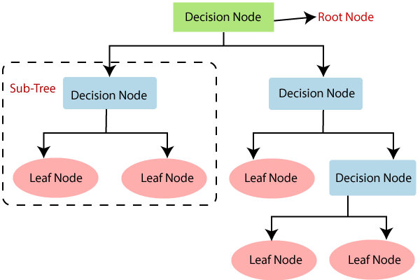

Decision Tree Terminologies
• Root Node: Root node is from where the decision tree starts. It represents the entire dataset, which further gets divided into two or more homogeneous sets.
• Leaf Node: Leaf nodes are the final output node, and the tree cannot be segregated further after getting a leaf node.
• Splitting: Splitting is the process of dividing the decision node/root node into sub-nodes according to the given conditions.
• Branch/Sub Tree: A tree formed by splitting the tree.
• Pruning: Pruning is the process of removing the unwanted branches from the tree.
• Parent/Child node: The root node of the tree is called the parent node, and other nodes are called the child nodes.
In a decision tree, for predicting the class of the given dataset, the algorithm starts from the root node of the tree. This algorithm compares the values of root attribute with the record (real dataset) attribute and, based on the comparison, follows the branch and jumps to the next node.
For the next node, the algorithm again compares the attribute value with the other sub-nodes and move further. It continues the process until it reaches the leaf node of the tree. The complete process can be better understood using the below algorithm:
- Step-1: Begin the tree with the root node, says S, which contains the complete dataset.
- Step-2: Find the best attribute in the dataset using Attribute Selection Measure (ASM).
- Step-3: Divide the S into subsets that contains possible values for the best attributes.
- Step-4: Generate the decision tree node, which contains the best attribute.
- Step-5: Recursively make new decision trees using the subsets of the dataset created in step -3. Continue this process until a stage is reached where you cannot further classify the nodes and called the final node as a leaf node.

Implementation of Decision Tree

# importing libraries
import numpy as nm
import matplotlib.pyplot as mtp
import pandas as pd
#importing datasets
data_set= pd.read_csv('user_data.csv')
#Extracting Independent and dependent Variable
x= data_set.iloc[:, [2,3]].values
y= data_set.iloc[:, 4].values

# Splitting the dataset into training and test set.
from sklearn.model_selection import train_test_split
x_train, x_test, y_train, y_test= train_test_split(x, y, test_size= 0.25, random_state=0)
#feature Scaling
from sklearn.preprocessing import StandardScaler
st_x= StandardScaler()
x_train= st_x.fit_transform(x_train)
x_test= st_x.transform(x_test)
#Fitting Decision Tree classifier to the training set
From sklearn.tree import DecisionTreeClassifier
classifier= DecisionTreeClassifier(criterion='entropy', random_state=0)
classifier.fit(x_train, y_train)
#Predicting the test set result
y_pred= classifier.predict(x_test)
#Creating the Confusion matrix
from sklearn.metrics import confusion_matrix

cm= confusion_matrix(y_test, y_pred)

#Visulaizing the test set result
from matplotlib.colors import ListedColormap
x_set, y_set = x_test, y_test
x1, x2 = nm.meshgrid(nm.arange(start = x_set[:, 0].min() - 1, stop = x_set[:, 0].max() + 1, step =0.01),
nm.arange(start = x_set[:, 1].min() - 1, stop = x_set[:, 1].max() + 1, step = 0.01))
mtp.contourf(x1, x2, classifier.predict(nm.array([x1.ravel(), x2.ravel()]).T).reshape(x1.shape),
alpha = 0.75, cmap = ListedColormap(('purple','green' )))
mtp.xlim(x1.min(), x1.max())
mtp.ylim(x2.min(), x2.max())
fori, j in enumerate(nm.unique(y_set)):
mtp.scatter(x_set[y_set == j, 0], x_set[y_set == j, 1],
c = ListedColormap(('purple', 'green'))(i), label = j)
mtp.title('Decision Tree Algorithm(Test set)')
mtp.xlabel('Age')
mtp.ylabel('Estimated Salary')
mtp.legend()
mtp.show()

Experiment No - 09

Title:- Implementation of SVM.
Aim: Implementation of SVM
Theory:-
Support Vector Machine or SVM is one of the most popular Supervised Learning algorithms, which is used for Classification as well as Regression problems. However, primarily, it is used for Classification problems in Machine Learning.
The goal of the SVM algorithm is to create the best line or decision boundary that can segregate n-dimensional space Iinto classes so that we can easily put the new data point in the correct category in the future. This best decision boundary is called a hyperplane.
SVM chooses the extreme points/vectors that help in creating the hyperplane. These extreme cases are called as support vectors, and hence algorithm is termed as Support Vector Machine. Consider the below diagram in which there are two different categories that are classified using a decision boundary or hyperplane
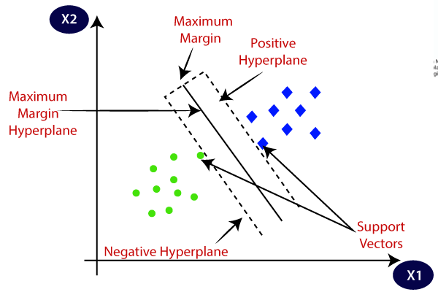

The working of the SVM algorithm can be understood by using an example. Suppose we have a dataset that has two tags (green and blue), and the dataset has two features x1 and x2. We want a classifier that can classify the pair(x1, x2) of coordinates in either green or blue. Consider the below image:
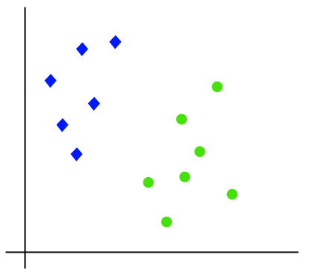
So as it is 2-d space so by just using a straight line, we can easily separate these two classes. But there can be multiple lines that can separate these classes. Consider the below image:
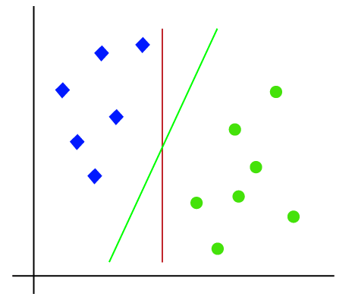
Hence, the SVM algorithm helps to find the best line or decision boundary; this best boundary or region is called as a hyperplane. SVM algorithm finds the closest point of the lines from both the classes. These points are called support vectors. The distance between the vectors and the hyperplane is called as margin. And the goal of SVM is to maximize this margin. The hyperplane with maximum margin is called the optimal hyperplane.
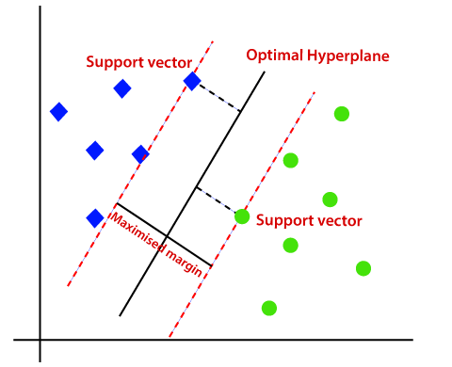
Implementation of Support Vector Machine
# Splitting the dataset into training and test set.
from sklearn.model_selection import train_test_split
x_train, x_test, y_train, y_test= train_test_split(x, y, test_size= 0.25, random_state=0)
#feature Scaling
from sklearn.preprocessing import StandardScaler
st_x= StandardScaler()
x_train= st_x.fit_transform(x_train)
x_test= st_x.transform(x_test)
from sklearn.svm import SVC # "Support vector classifier"
classifier = SVC(kernel='linear', random_state=0)
classifier.fit(x_train, y_train)
Out[8]:
SVC(C=1.0, cache_size=200, class_weight=None, coef0=0.0,
decision_function_shape='ovr', degree=3, gamma='auto_deprecated',
kernel='linear', max_iter=-1, probability=False, random_state=0,
shrinking=True, tol=0.001, verbose=False)

#Predicting the test set result
y_pred= classifier.predict(x_test)
#Creating the Confusion matrix
from sklearn.metrics import confusion_matrix
cm= confusion_matrix(y_test, y_pred)

from matplotlib.colors import ListedColormap
x_set, y_set = x_train, y_train
x1, x2 = nm.meshgrid(nm.arange(start = x_set[:, 0].min() - 1, stop = x_set[:, 0].max() + 1, step =0.01),
nm.arange(start = x_set[:, 1].min() - 1, stop = x_set[:, 1].max() + 1, step = 0.01))
mtp.contourf(x1, x2, classifier.predict(nm.array([x1.ravel(), x2.ravel()]).T).reshape(x1.shape),
alpha = 0.75, cmap = ListedColormap(('red', 'green')))
mtp.xlim(x1.min(), x1.max())
mtp.ylim(x2.min(), x2.max())
for i, j in enumerate(nm.unique(y_set)):
mtp.scatter(x_set[y_set == j, 0], x_set[y_set == j, 1],
c = ListedColormap(('red', 'green'))(i), label = j)
mtp.title('SVM classifier (Training set)')
mtp.xlabel('Age')
mtp.ylabel('Estimated Salary')
mtp.legend()
mtp.show()

Experiment No - 10

Title:- Implementation of K-means Clustering
Aim: Implementation of K-means Clustering
Theory:-
K-Means Clustering is an Unsupervised Learning algorithm, which groups the unlabeled dataset into different clusters. Here K defines the number of pre-defined clusters that need to be created in the process, as if K=2, there will be two clusters, and for K=3, there will be three clusters, and so on.
It allows us to cluster the data into different groups and a convenient way to discover the categories of groups in the unlabeled dataset on its own without the need for any training.
It is a centroid-based algorithm, where each cluster is associated with a centroid. The main aim of this algorithm is to minimize the sum of distances between the data point and their corresponding clusters.
The algorithm takes the unlabeled dataset as input, divides the dataset into k-number of clusters, and repeats the process until it does not find the best clusters. The value of k should be predetermined in this algorithm.
The k-means clustering algorithm mainly performs two tasks:
- Determines the best value for K center points or centroids by an iterative process.
- Assigns each data point to its closest k-center. Those data points which are near to the particular k-center, create a cluster.
Hence each cluster has datapoints with some commonalities, and it is away from other clusters.
The below diagram explains the working of the K-means Clustering Algorithm:
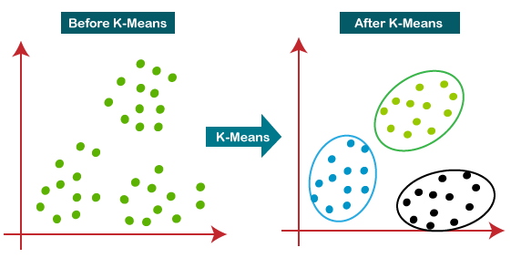
The working of the K-Means algorithm is explained in the below steps:
Step-1: Select the number K to decide the number of clusters.
Step-2: Select random K points or centroids. (It can be other from the input dataset).
Step-3: Assign each data point to their closest centroid, which will form the predefined K clusters.
Step-4: Calculate the variance and place a new centroid of each cluster.
Step-5: Repeat the third steps, which means reassign each datapoint to the new closest centroid of each cluster.
Step-6: If any reassignment occurs, then go to step-4 else go to FINISH.
Step-7: The model is ready.

Implementation of K-means Clustering Algorithm
# importing libraries
import numpy as nm
import matplotlib.pyplot as mtp
import pandas as pd
# Importing the dataset
dataset = pd.read_csv('Mall_Customers_data.csv')
x = dataset.iloc[:, [3, 4]].values
#finding optimal number of clusters using the elbow method
from sklearn.cluster import KMeans
wcss_list= [] #Initializing the list for the values of WCSS

#Using for loop for iterations from 1 to 10.
for i in range(1, 11):
kmeans = KMeans(n_clusters=i, init='k-means++', random_state= 42)
kmeans.fit(x)
wcss_list.append(kmeans.inertia_)
mtp.plot(range(1, 11), wcss_list)
mtp.title('The Elobw Method Graph')
mtp.xlabel('Number of clusters(k)')
mtp.ylabel('wcss_list')
mtp.show()

Experiment No-11

Title: Implementation of Agglomerative Clustering
Aim: Implementation of Agglomerative Clustering

Theory:-
Hierarchical clustering is another unsupervised machine learning algorithm, which is used to group the unlabeled datasets into a cluster and also known as hierarchical cluster analysis or HCA.
In this algorithm, we develop the hierarchy of clusters in the form of a tree, and this tree-shaped structure is known as the dendrogram.
Sometimes the results of K-means clustering and hierarchical clustering may look similar, but they both differ depending on how they work. As there is no requirement to predetermine the number of clusters as we did in the K-Means algorithm.
The hierarchical clustering technique has two approaches:
- Agglomerative: Agglomerative is a bottom-up approach, in which the algorithm starts with taking all data points as single clusters and merging them until one cluster is left.
- Divisive: Divisive algorithm is the reverse of the agglomerative algorithm as it is a top-down approach.

Agglomerative Hierarchical clustering
The agglomerative hierarchical clustering algorithm is a popular example of HCA. To group the datasets into clusters, it follows the bottom-up approach. It means, this algorithm considers each dataset as a single cluster at the beginning, and then start combining the closest pair of clusters together. It does this until all the clusters are merged into a single cluster that contains all the datasets.
This hierarchy of clusters is represented in the form of the dendrogram.
# Importing the libraries
import numpy as nm
import matplotlib.pyplot as mtp
import pandas as pd
# Importing the dataset
dataset = pd.read_csv('Mall_Customers_data.csv')
x = dataset.iloc[:, [3, 4]].values
#Finding the optimal number of clusters using the dendrogram
import scipy.cluster.hierarchy as shc
dendro = shc.dendrogram(shc.linkage(x, method="ward"))
mtp.title("Dendrogrma Plot")
mtp.ylabel("Euclidean Distances")
mtp.xlabel("Customers")
mtp.show()
#training the hierarchical model on dataset

from sklearn.cluster import AgglomerativeClustering
hc= AgglomerativeClustering(n_clusters=5, affinity='euclidean', linkage='ward')

y_pred= hc.fit_predict(x)
#visulaizing the clusters
mtp.scatter(x[y_pred == 0, 0], x[y_pred == 0, 1], s = 100, c = 'blue', label = 'Cluster 1')
mtp.scatter(x[y_pred == 1, 0], x[y_pred == 1, 1], s = 100, c = 'green', label = 'Cluster 2')
mtp.scatter(x[y_pred== 2, 0], x[y_pred == 2, 1], s = 100, c = 'red', label = 'Cluster 3')
mtp.scatter(x[y_pred == 3, 0], x[y_pred == 3, 1], s = 100, c = 'cyan', label = 'Cluster 4')
mtp.scatter(x[y_pred == 4, 0], x[y_pred == 4, 1], s = 100, c = 'magenta', label = 'Cluster 5')
mtp.title('Clusters of customers')
mtp.xlabel('Annual Income (k$)')
mtp.ylabel('Spending Score (1-100)')
mtp.legend()
mtp.show()

Experiment No-12
Title: Implementation of Design and analysis of sentiment analysis model
Aim: Implementation of Design and analysis of sentiment analysis model

Theory:-

Sentiment analysis is a popular task in natural language processing. The goal of sentiment analysis is to classify the text based on the mood or mentality expressed in the text, which can be positive negative, or neutral.

It is the process of classifying whether a block of text is positive, negative, or, neutral. The goal which Sentiment analysis tries to gain is to be analyzed people’s opinions in a way that can help businesses expand. It focuses not only on polarity (positive, negative & neutral) but also on emotions (happy, sad, angry, etc.). It uses various Natural Language Processing algorithms such as Rule-based, Automatic, and Hybrid.

Sentiment analysis is the contextual meaning of words that indicates the social sentiment of a brand and also helps the business to determine whether the product they are manufacturing is going to make a demand in the market or not.
There are three approaches used:
- Rule-based approach: Over here, the lexicon method, tokenization, and parsing come in the rule-based. The approach is that counts the number of positive and negative words in the given dataset. If the number of positive words is greater than the number of negative words then the sentiment is positive else vice-versa.
- Machine Learning Approach: This approach works on the machine learning technique. Firstly, the datasets are trained and predictive analysis is done. The next process is the extraction of words from the text is done. This text extraction can be done using different techniques such as Naive Bayes, Support Vector machines, hidden Markov model, and conditional random fields like this machine learning techniques are used.
- Neural network Approach: In the last few years neural networks have evolved at a very rate. It involves using artificial neural networks, which are inspired by the structure of the human brain, to classify text into positive, negative, or neutral sentiments. it has Recurrent neural networks, Long short-term memory, Gated recurrent unit, etc to process sequential data like text.
- Hybrid Approach: It is the combination of two or more approaches i.e. rule-based and Machine Learning approaches. The surplus is that the accuracy is high compared to the other two approaches.

